**Solution Processes and Design**

**Requirement Collection and Analysis**

**Users of the system:**

Listed below are the main users of the pharmacy management system. They are required to register into the system to access records and details stored in the database. Only the head admin has the privilege or access over all records and users. The system access to other users in restricted as per their functions in the medical store.

* Admin
* Manager
* Cashier
* Pharmacist

**List of forms:**

* Log in and Log out
* Add, edit, update, and delete users
* Invoice
* Prescription: view and delete
* Stock: view and delete
* Stock pharmacist

Function of the Admin

* Admin Can Manage All users
* Admin Can Manage Manager
* Admin Can Manage Cashier
* Admin Can Manage Pharmacist

Function of the Manager

* View Users
* View Prescriptions
* Manage Stock

Function of the Pharmacist

* Manage Prescriptions
* Manage Stock

Function of the Cashier

Process Payment

**STRUCTURE CHART**

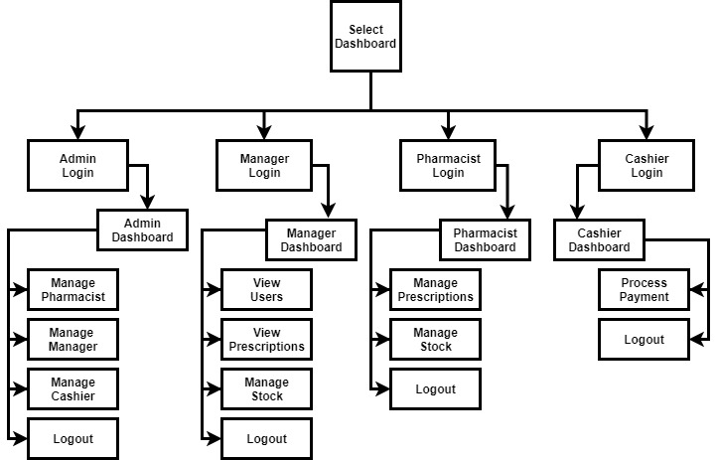

**SYSTEM FLOWCHART**

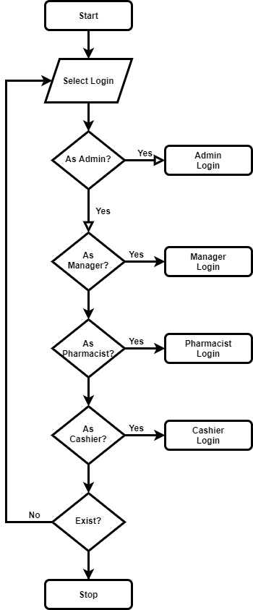

***Use case description for Login to System for admin***

***Use case name*** Login to System

***Summary*** System validates the Head admin

***Actor*** the Admin

***Precondition*** the login page must be displayed

***Flow of Event:***

This use case starts when a Head admin is not logged in to the system and goes to the login page.

1. The Head admin going to the login menu and click on it.

2. System prompts the Head admin for username and password

3. The Head admin inserts username and password to the fields.

4. System checks the username and password.

5. If the input were valid value then system will display general system of the pharmacy system.

***Alternate Flows:***

Step 5: if the username or password is not correct, the System displays an

Error message. And prompts for the correct username and password.

Step 5: if the Head admin tries to insert username and Password three times

Without restarting the System, it will close.

Step 1-4: if the user clicks on cancel, the system will go on the pharmacy Navigation page.

**Post condition:** username and password of the Head admin is Validated.

**ADDMIN LOGIN FLOWCHART**

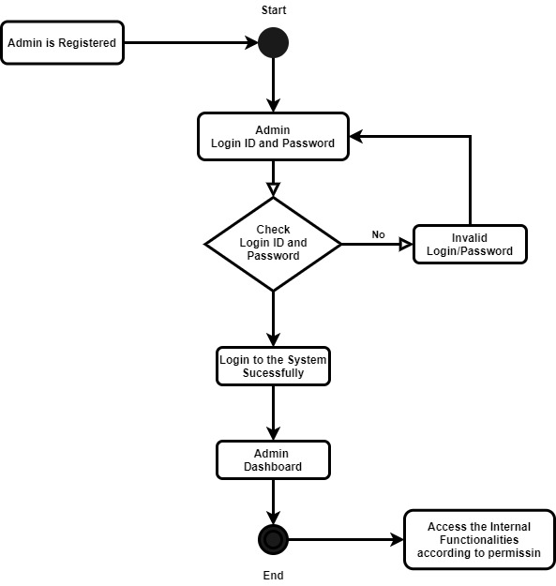

***Use case description for Login to System for manager***

***Use case name*** Login to System for manager admin

***Summary*** System validates the manager admin

***Actor*** the manager admin

***Precondition*** the login page must be displayed

***Flow of Event:***

This use case starts when the manager admin is not logged in to the system and goes to the login page.

1. The manager admin going to the login menu and click on it.

2. System prompts the user for username and password

3. The manager admin inserts username and password to the fields.

4. System checks the username and password.

5. If the input were valid value then system will display general system of the pharmacy system.

***Alternate Flows:***

Step 5: if the username or password is not correct, the System displays an

Error message. And prompts for the correct username and password.

Step 5: if the manager admin tries to insert username and Password three times

Without restarting the System, it will close.

Step 1-4: if the manager admin clicks on cancel, the system will go on the pharmacy Navigation page.

**Post condition:** username and password of the manager admin is Validated. **Login Activity**

**MANAGER LOGIN FLOWCHART**

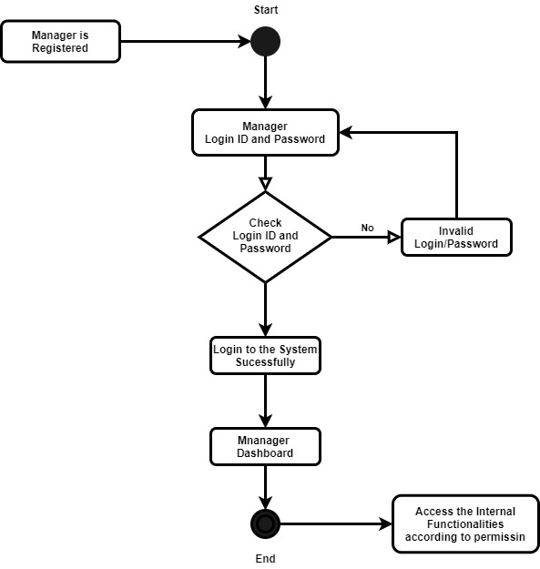

***Use case description for Login to System for Pharmacist***

***Use case name*** Login to System

***Summary*** System validates the Pharmacist admin

***Actor*** the Pharmacist

***Precondition*** the login page must be displayed

***Flow of Event:***

This use case starts when the pharmacist admin is not logged in to the system and goes to the login page.

1. The Pharmacist admingoing to the login menu and click on it.

2. System prompts the Pharmacist adminusername and password

3. The Pharmacist admininserts username and password to the fields.

4. System checks the username and password.

5. If the input were valid value then system will display general system of the pharmacy system.

***Alternate Flows:***

Step 5: if the username or password is not correct, the System displays an

Error message. And prompts for the correct username and password.

Step 5: if the Pharmacist admin tries to insert username and Password three times

Without restarting the System, it will close.

Step 1-4: if the Pharmacist adminclicks on cancel, the system will go on the pharmacy Navigation page.

**Post condition:** username and password of the Pharmacist admin is Validated.

**PHARMACIST LOGIN FLOWCHART**

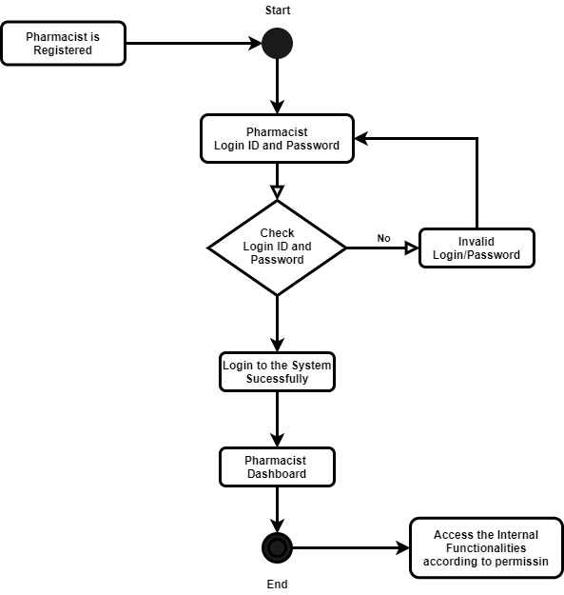

***Use case description for Login to System for cashier***

***Use case name*** Login to System for Cashier

***Summary*** System validates the Cashier admin

***Actor*** the **cashier**

***Precondition*** the login page must be displayed

***Flow of Event:***

This use case starts when the cashier admin is not logged in to the system and goes to the login page.

1. The pharmacy manager going to the login menu and click on it.

2. System prompts the Cashier admin for username and password

3. The pharmacy manager inserts username and password to the fields.

4. System checks the username and password.

5. If the input were valid value then system will display general system of the pharmacy system.

***Alternate Flows:***

Step 5: if the username or password is not correct, the System displays an

Error message. And prompts for the correct username and password.

Step 5: if the Cashier admin tries to insert username and Password three times

Without restarting the System, it will close.

Step 1-4: if the Cashier admin clicks on cancel, the system will go on the pharmacy Navigation page.

**Post condition:** username and password of the Cashier admin is Validated.

**CASHIER LOGIN FLOWCHART**

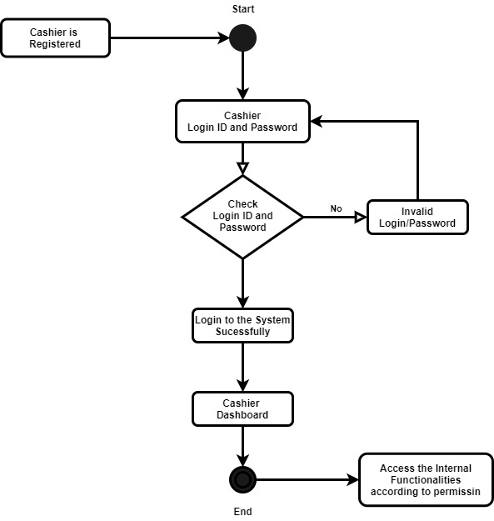

***Use case description the Head admin of the System modifies the system***

***Use case name*** modifies the system

***Summary*** the Head admin of the System modifies the system in the database

***Actor*** the Head admin

***Flow of Event:***

This use case starts when the Head admin accesses the system.

1. The System displays the current list of record.
2. The head admin selects the record he/she wants to modify.
3. The system displays the corresponding information.
4. The head admin edits the information accordingly and submits.
5. The system updates the information.

Use Case ends.

***Alternate Flows:***

1. The system displays an “Invalid Information” error after the Head admin submits the information and asks the head admin to re-enter the information.
2. The Head admin re-enters information and clicks submit.

**Usecase Diagram of Pharmacy Management System**

